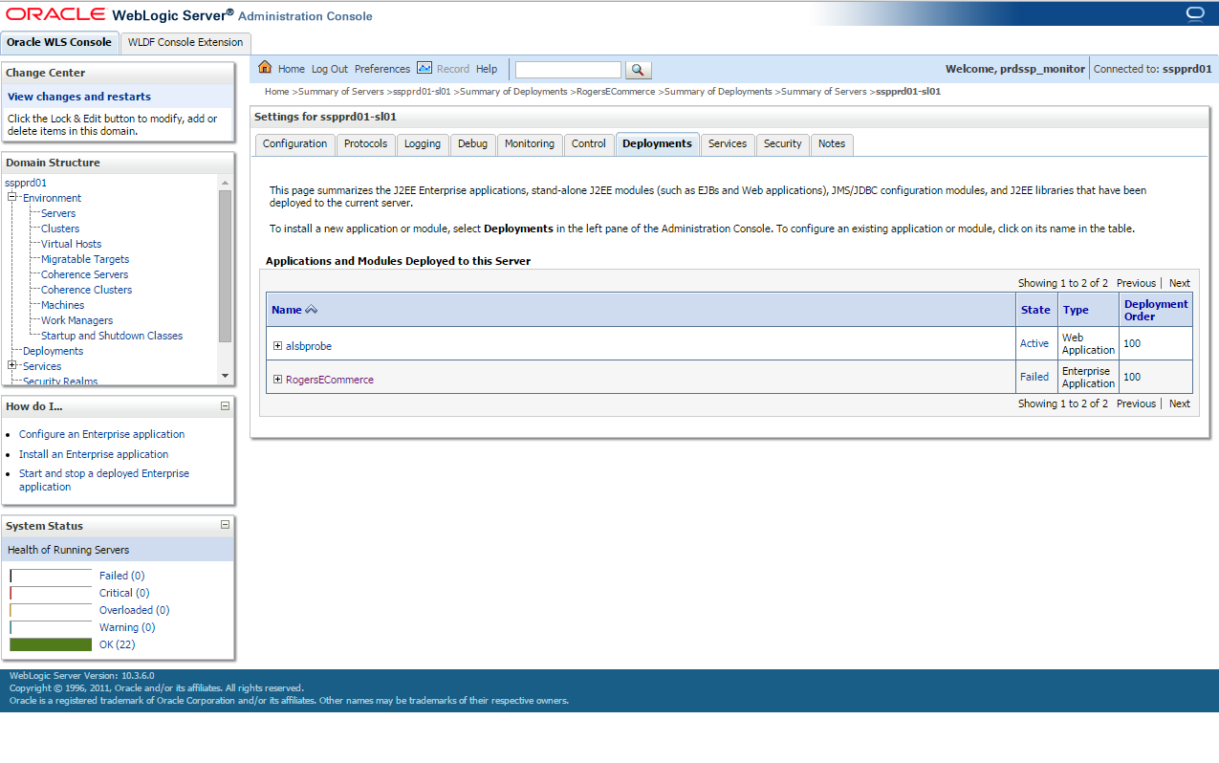

<Jun 4, 2015 1:04:52 AM EDT> <Warning> <Munger> <BEA-2156203> <A version attribute was not found in element application in the deployment descriptor in /app/domains/prdssp/sspprd01/servers/sspprd01-sl01/stage/RogersECommerce/RogersECommerce.ear/META-INF/application.xml. A version attribute is required, but this version of the Weblogic Server will assume that the JEE5 is used. Future versions of the Weblogic Server will reject descriptors that do not specify the JEE version.>

<Jun 4, 2015 1:04:54 AM EDT> <Warning> <Munger> <BEA-2156203> <A version attribute was not found in element application in the deployment descriptor in /app/domains/prdssp/sspprd01/servers/sspprd01-sl01/stage/RogersECommerce/RogersECommerce.ear/META-INF/application.xml. A version attribute is required, but this version of the Weblogic Server will assume that the JEE5 is used. Future versions of the Weblogic Server will reject descriptors that do not specify the JEE version.>

<Jun 4, 2015 1:04:54 AM EDT> <Info> <Deployer> <BEA-149059> <Module tfamm of application RogersECommerce is transitioning from STATE_NEW to STATE_PREPARED on server sspprd01-sl01.>

<Jun 4, 2015 1:04:55 AM EDT> <Error> <HTTP> <BEA-101163> <Could not load user defined listener: com.cgi.core.servlet.listener.ApplicationStartupListener

java.lang.ClassNotFoundException: com.cgi.core.servlet.listener.ApplicationStartupListener

at weblogic.utils.classloaders.GenericClassLoader.findLocalClass(GenericClassLoader.java:297)

at weblogic.utils.classloaders.GenericClassLoader.findClass(GenericClassLoader.java:270)

at weblogic.utils.classloaders.ChangeAwareClassLoader.findClass(ChangeAwareClassLoader.java:64)

at java.lang.ClassLoader.loadClass(ClassLoader.java:306)

at java.lang.ClassLoader.loadClass(ClassLoader.java:247)

at weblogic.utils.classloaders.GenericClassLoader.loadClass(GenericClassLoader.java:179)

at weblogic.utils.classloaders.ChangeAwareClassLoader.loadClass(ChangeAwareClassLoader.java:43)

at weblogic.servlet.internal.EventsManager.registerEventListeners(EventsManager.java:123)

at weblogic.servlet.internal.EventsManager.registerPreparePhaseListeners(EventsManager.java:71)

at weblogic.servlet.internal.WebAppServletContext.initContextListeners(WebAppServletContext.java:1851)

at weblogic.servlet.internal.WebAppServletContext.prepare(WebAppServletContext.java:1201)

at weblogic.servlet.internal.HttpServer.doPostContextInit(HttpServer.java:457)

at weblogic.servlet.internal.HttpServer.loadWebApp(HttpServer.java:432)

at weblogic.servlet.internal.WebAppModule.registerWebApp(WebAppModule.java:985)

at weblogic.servlet.internal.WebAppModule.prepare(WebAppModule.java:387)

at weblogic.application.internal.flow.ScopedModuleDriver.prepare(ScopedModuleDriver.java:176)

at weblogic.application.internal.flow.ModuleListenerInvoker.prepare(ModuleListenerInvoker.java:199)

at weblogic.application.internal.flow.DeploymentCallbackFlow$1.next(DeploymentCallbackFlow.java:517)

at weblogic.application.utils.StateMachineDriver.nextState(StateMachineDriver.java:52)

at weblogic.application.internal.flow.DeploymentCallbackFlow.prepare(DeploymentCallbackFlow.java:159)

at weblogic.application.internal.flow.DeploymentCallbackFlow.prepare(DeploymentCallbackFlow.java:45)

at weblogic.application.internal.BaseDeployment$1.next(BaseDeployment.java:648)

at weblogic.application.utils.StateMachineDriver.nextState(StateMachineDriver.java:52)

at weblogic.application.internal.BaseDeployment.prepare(BaseDeployment.java:191)

at weblogic.application.internal.EarDeployment.prepare(EarDeployment.java:59)

at weblogic.application.internal.DeploymentStateChecker.prepare(DeploymentStateChecker.java:154)

at weblogic.deploy.internal.targetserver.AppContainerInvoker.prepare(AppContainerInvoker.java:61)

at weblogic.deploy.internal.targetserver.AppDeployment.prepare(AppDeployment.java:144)

at weblogic.management.deploy.internal.DeploymentAdapter$1.doPrepare(DeploymentAdapter.java:39)

at weblogic.management.deploy.internal.DeploymentAdapter.prepare(DeploymentAdapter.java:191)

at weblogic.management.deploy.internal.AppTransition$1.transitionApp(AppTransition.java:21)

at weblogic.management.deploy.internal.ConfiguredDeployments.transitionApps(ConfiguredDeployments.java:240)

at weblogic.management.deploy.internal.ConfiguredDeployments.prepare(ConfiguredDeployments.java:165)

at weblogic.management.deploy.internal.ConfiguredDeployments.deploy(ConfiguredDeployments.java:122)

at weblogic.management.deploy.internal.DeploymentServerService.resume(DeploymentServerService.java:180)

at weblogic.management.deploy.internal.DeploymentServerService.start(DeploymentServerService.java:96)

at weblogic.t3.srvr.SubsystemRequest.run(SubsystemRequest.java:64)

at weblogic.work.ExecuteThread.execute(ExecuteThread.java:256)

at weblogic.work.ExecuteThread.run(ExecuteThread.java:221)

>

<Jun 4, 2015 1:04:55 AM EDT> <Info> <Deployer> <BEA-149061> <Module tfamm of application RogersECommerce failed to transition from STATE_NEW to STATE_PREPARED on server sspprd01-sl01.>

<Jun 4, 2015 1:04:55 AM EDT> <Error> <Deployer> <BEA-149205> <Failed to initialize the application 'RogersECommerce' due to error weblogic.application.ModuleException: java.lang.ClassNotFoundException: com.cgi.core.servlet.listener.ApplicationStartupListener.

weblogic.application.ModuleException: java.lang.ClassNotFoundException: com.cgi.core.servlet.listener.ApplicationStartupListener

at weblogic.servlet.internal.WebAppModule.prepare(WebAppModule.java:397)

at weblogic.application.internal.flow.ScopedModuleDriver.prepare(ScopedModuleDriver.java:176)

at weblogic.application.internal.flow.ModuleListenerInvoker.prepare(ModuleListenerInvoker.java:199)

at weblogic.application.internal.flow.DeploymentCallbackFlow$1.next(DeploymentCallbackFlow.java:517)

at weblogic.application.utils.StateMachineDriver.nextState(StateMachineDriver.java:52)

at weblogic.application.internal.flow.DeploymentCallbackFlow.prepare(DeploymentCallbackFlow.java:159)

at weblogic.application.internal.flow.DeploymentCallbackFlow.prepare(DeploymentCallbackFlow.java:45)

at weblogic.application.internal.BaseDeployment$1.next(BaseDeployment.java:648)

at weblogic.application.utils.StateMachineDriver.nextState(StateMachineDriver.java:52)

at weblogic.application.internal.BaseDeployment.prepare(BaseDeployment.java:191)

at weblogic.application.internal.EarDeployment.prepare(EarDeployment.java:59)

at weblogic.application.internal.DeploymentStateChecker.prepare(DeploymentStateChecker.java:154)

at weblogic.deploy.internal.targetserver.AppContainerInvoker.prepare(AppContainerInvoker.java:61)

at weblogic.deploy.internal.targetserver.AppDeployment.prepare(AppDeployment.java:144)

at weblogic.management.deploy.internal.DeploymentAdapter$1.doPrepare(DeploymentAdapter.java:39)

at weblogic.management.deploy.internal.DeploymentAdapter.prepare(DeploymentAdapter.java:191)

at weblogic.management.deploy.internal.AppTransition$1.transitionApp(AppTransition.java:21)

at weblogic.management.deploy.internal.ConfiguredDeployments.transitionApps(ConfiguredDeployments.java:240)

at weblogic.management.deploy.internal.ConfiguredDeployments.prepare(ConfiguredDeployments.java:165)

at weblogic.management.deploy.internal.ConfiguredDeployments.deploy(ConfiguredDeployments.java:122)

at weblogic.management.deploy.internal.DeploymentServerService.resume(DeploymentServerService.java:180)

at weblogic.management.deploy.internal.DeploymentServerService.start(DeploymentServerService.java:96)

at weblogic.t3.srvr.SubsystemRequest.run(SubsystemRequest.java:64)

at weblogic.work.ExecuteThread.execute(ExecuteThread.java:256)

at weblogic.work.ExecuteThread.run(ExecuteThread.java:221)

Caused By: java.lang.ClassNotFoundException: com.cgi.core.servlet.listener.ApplicationStartupListener

at weblogic.utils.classloaders.GenericClassLoader.findLocalClass(GenericClassLoader.java:297)

at weblogic.utils.classloaders.GenericClassLoader.findClass(GenericClassLoader.java:270)

at weblogic.utils.classloaders.ChangeAwareClassLoader.findClass(ChangeAwareClassLoader.java:64)

at java.lang.ClassLoader.loadClass(ClassLoader.java:306)

at java.lang.ClassLoader.loadClass(ClassLoader.java:247)

at weblogic.utils.classloaders.GenericClassLoader.loadClass(GenericClassLoader.java:179)

at weblogic.utils.classloaders.ChangeAwareClassLoader.loadClass(ChangeAwareClassLoader.java:43)

at weblogic.servlet.internal.EventsManager.registerEventListeners(EventsManager.java:123)

at weblogic.servlet.internal.EventsManager.registerPreparePhaseListeners(EventsManager.java:71)

at weblogic.servlet.internal.WebAppServletContext.initContextListeners(WebAppServletContext.java:1851)

at weblogic.servlet.internal.WebAppServletContext.prepare(WebAppServletContext.java:1201)

at weblogic.servlet.internal.HttpServer.doPostContextInit(HttpServer.java:457)

at weblogic.servlet.internal.HttpServer.loadWebApp(HttpServer.java:432)

at weblogic.servlet.internal.WebAppModule.registerWebApp(WebAppModule.java:985)

at weblogic.servlet.internal.WebAppModule.prepare(WebAppModule.java:387)

at weblogic.application.internal.flow.ScopedModuleDriver.prepare(ScopedModuleDriver.java:176)

at weblogic.application.internal.flow.ModuleListenerInvoker.prepare(ModuleListenerInvoker.java:199)

at weblogic.application.internal.flow.DeploymentCallbackFlow$1.next(DeploymentCallbackFlow.java:517)

at weblogic.application.utils.StateMachineDriver.nextState(StateMachineDriver.java:52)

at weblogic.application.internal.flow.DeploymentCallbackFlow.prepare(DeploymentCallbackFlow.java:159)

at weblogic.application.internal.flow.DeploymentCallbackFlow.prepare(DeploymentCallbackFlow.java:45)

at weblogic.application.internal.BaseDeployment$1.next(BaseDeployment.java:648)

at weblogic.application.utils.StateMachineDriver.nextState(StateMachineDriver.java:52)

at weblogic.application.internal.BaseDeployment.prepare(BaseDeployment.java:191)

at weblogic.application.internal.EarDeployment.prepare(EarDeployment.java:59)

at weblogic.application.internal.DeploymentStateChecker.prepare(DeploymentStateChecker.java:154)

at weblogic.deploy.internal.targetserver.AppContainerInvoker.prepare(AppContainerInvoker.java:61)

at weblogic.deploy.internal.targetserver.AppDeployment.prepare(AppDeployment.java:144)

at weblogic.management.deploy.internal.DeploymentAdapter$1.doPrepare(DeploymentAdapter.java:39)

at weblogic.management.deploy.internal.DeploymentAdapter.prepare(DeploymentAdapter.java:191)

at weblogic.management.deploy.internal.AppTransition$1.transitionApp(AppTransition.java:21)

at weblogic.management.deploy.internal.ConfiguredDeployments.transitionApps(ConfiguredDeployments.java:240)

at weblogic.management.deploy.internal.ConfiguredDeployments.prepare(ConfiguredDeployments.java:165)

at weblogic.management.deploy.internal.ConfiguredDeployments.deploy(ConfiguredDeployments.java:122)

at weblogic.management.deploy.internal.DeploymentServerService.resume(DeploymentServerService.java:180)

at weblogic.management.deploy.internal.DeploymentServerService.start(DeploymentServerService.java:96)

at weblogic.t3.srvr.SubsystemRequest.run(SubsystemRequest.java:64)

at weblogic.work.ExecuteThread.execute(ExecuteThread.java:256)

at weblogic.work.ExecuteThread.run(ExecuteThread.java:221)

>

<Jun 4, 2015 1:04:55 AM EDT> <Info> <Deployer> <BEA-149059> <Module alsbprobe.war of application alsbprobe is transitioning from STATE_NEW to STATE_PREPARED on server sspprd01-sl01.>

<Jun 4, 2015 1:04:55 AM EDT> <Info> <Deployer> <BEA-149060> <Module alsbprobe.war of application alsbprobe successfully transitioned from STATE_NEW to STATE_PREPARED on server sspprd01-sl01.>

<Jun 4, 2015 1:04:56 AM EDT> <Info> <WebService> <BEA-220103> <Async web service support is not fully configured. The async response web service /AsyncResponseServiceHttps for this server was not fully deployed because the JMS reliability queue was not defined/deployed: weblogic.wsee.DefaultQueue. The server will periodically retry completing the deploy for the service. This message can usually be ignored unless there are async web service applications. To completely disable async web service support, thus avoiding this message, set -Dweblogic.wsee.skip.async.response=true.>

<Jun 4, 2015 1:04:56 AM EDT> <Info> <WebService> <BEA-220103> <Async web service support is not fully configured. The async response web service /AsyncResponseServiceJms for this server was not fully deployed because the JMS reliability queue was not defined/deployed: weblogic.wsee.DefaultQueue. The server will periodically retry completing the deploy for the service. This message can usually be ignored unless there are async web service applications. To completely disable async web service support, thus avoiding this message, set -Dweblogic.wsee.skip.async.response=true.>

<Jun 4, 2015 1:04:56 AM EDT> <Info> <WebService> <BEA-220103> <Async web service support is not fully configured. The async response web service /AsyncResponseService for this server was not fully deployed because the JMS reliability queue was not defined/deployed: weblogic.wsee.DefaultQueue. The server will periodically retry completing the deploy for the service. This message can usually be ignored unless there are async web service applications. To completely disable async web service support, thus avoiding this message, set -Dweblogic.wsee.skip.async.response=true.>

<Jun 4, 2015 1:04:56 AM EDT> <Info> <WebService> <BEA-220103> <Async web service support is not fully configured. The async response web service /AsyncResponseServiceSoap12Jms for this server was not fully deployed because the JMS reliability queue was not defined/deployed: weblogic.wsee.DefaultQueue. The server will periodically retry completing the deploy for the service. This message can usually be ignored unless there are async web service applications. To completely disable async web service support, thus avoiding this message, set -Dweblogic.wsee.skip.async.response=true.>

<Jun 4, 2015 1:04:56 AM EDT> <Info> <WebService> <BEA-220103> <Async web service support is not fully configured. The async response web service /AsyncResponseServiceSoap12 for this server was not fully deployed because the JMS reliability queue was not defined/deployed: weblogic.wsee.DefaultQueue. The server will periodically retry completing the deploy for the service. This message can usually be ignored unless there are async web service applications. To completely disable async web service support, thus avoiding this message, set -Dweblogic.wsee.skip.async.response=true.>

<Jun 4, 2015 1:04:56 AM EDT> <Info> <WebService> <BEA-220103> <Async web service support is not fully configured. The async response web service /AsyncResponseServiceSoap12Https for this server was not fully deployed because the JMS reliability queue was not defined/deployed: weblogic.wsee.DefaultQueue. The server will periodically retry completing the deploy for the service. This message can usually be ignored unless there are async web service applications. To completely disable async web service support, thus avoiding this message, set -Dweblogic.wsee.skip.async.response=true.>

<Jun 4, 2015 1:04:56 AM EDT> <Info> <WebLogicServer> <BEA-000256> <Invoking weblogic.transaction.internal.StartupClass.main(null)>

<Jun 4, 2015 1:04:56 AM EDT> <Info> <Deployer> <BEA-149059> <Module alsbprobe.war of application alsbprobe is transitioning from STATE_PREPARED to STATE_ADMIN on server sspprd01-sl01.>

<Jun 4, 2015 1:04:56 AM EDT> <Info> <Deployer> <BEA-149060> <Module alsbprobe.war of application alsbprobe successfully transitioned from STATE_PREPARED to STATE_ADMIN on server sspprd01-sl01.>

<Jun 4, 2015 1:04:56 AM EDT> <Info> <Diagnostics> <BEA-320000> <The Diagnostics subsystem is initializing on Server sspprd01-sl01.>

<Jun 4, 2015 1:04:56 AM EDT> <Notice> <Log Management> <BEA-170027> <The Server has established connection with the Domain level Diagnostic Service successfully.>

<Jun 4, 2015 1:04:56 AM EDT> <Info> <Diagnostics> <BEA-320077> <Initialized the Diagnostic Accessor Service.>

<Jun 4, 2015 1:04:57 AM EDT> <Notice> <WebLogicServer> <BEA-000365> <Server state changed to ADMIN>

<Jun 4, 2015 1:04:57 AM EDT> <Notice> <WebLogicServer> <BEA-000365> <Server state changed to RESUMING>

